**Assignment Link:**

[**https://us1.ca.analytics.ibm.com/bi/?perspective=explore&pathRef=.my_folders%2FAssignment1.exp&subView=model000001836399c135_00000004**](https://us1.ca.analytics.ibm.com/bi/?perspective=explore&pathRef=.my_folders%2FAssignment1.exp&subView=model000001836399c135_00000004)

**R&D Spending:**

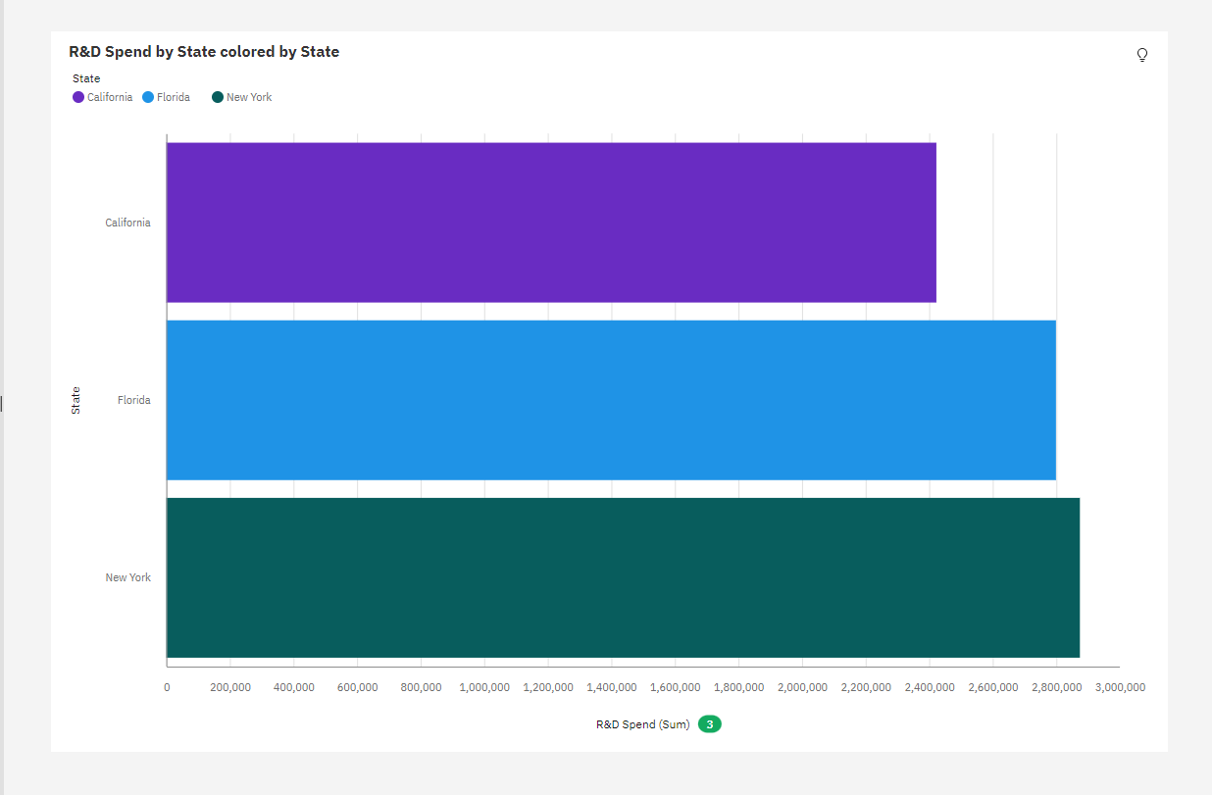

**Administration Spending:**

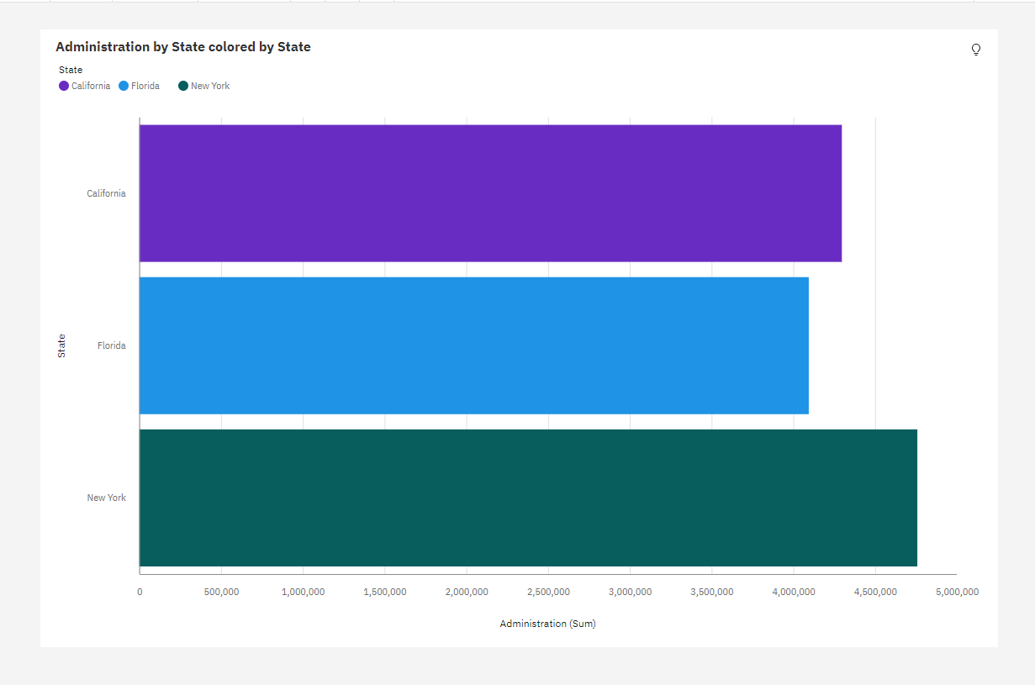

**Marketing Spending:**

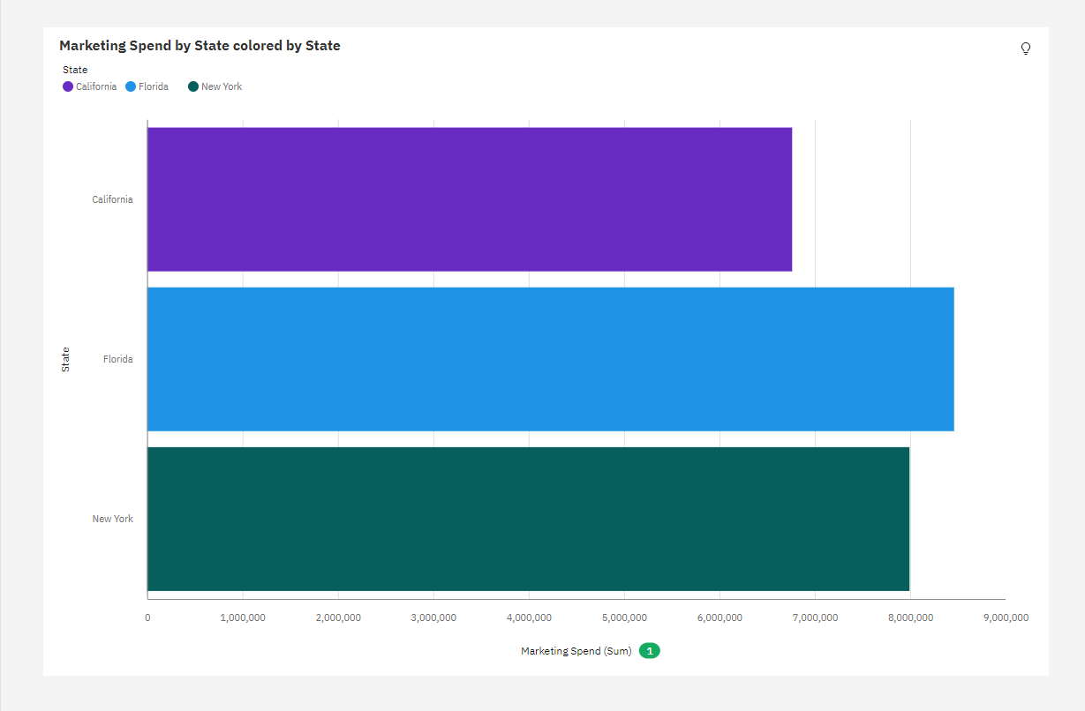

**State:**

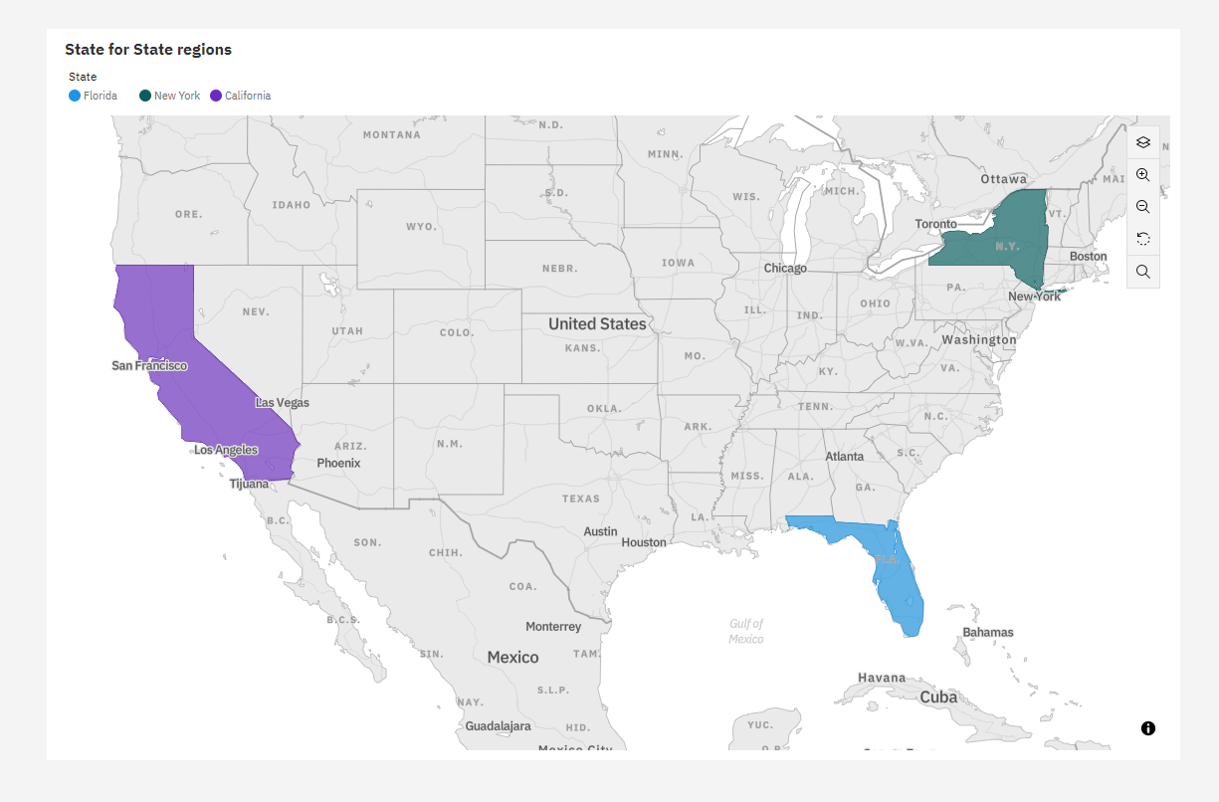

**Profit:**

